**Geometry 2025-2026**

**Ms. Micheale Jenkins**

**Ms. Kathy Morgan**

**Email address:**[**jenkimi@boe.richmond.k12.ga.us**](mailto:jenkimi@boe.richmond.k12.ga.us)**,** [**morgaka@boe.richmond.k12.ga.us**](mailto:morgaka@boe.richmond.k12.ga.us)**,**

**Phone Number: (706)-592-2089      Planning Period: 1th  Period**

**Course Description and Objectives**

In Geometry: Concepts & Connections, instructional time should regularly incorporate the 8 Mathematical Practices, the Framework for Statistical Reasoning, and the Mathematical Modeling Framework through four big ideas of content: (1) numerical reasoning, (2) functional & graphical reasoning, (3) patterning and algebraic reasoning, and (4) geometric and spatial reasoning. This course is designed as the second course in a three-course series. Students will apply their algebraic and geometric reasoning skills to make sense of problems involving geometry, trigonometry, algebra, probability, and statistics. This course enhances students’ geometric, algebraic, graphical, and probabilistic reasoning skills. Students will apply their algebraic and geometric reasoning skills to make sense of problems involving geometry, trigonometry, algebra, probability, and statistics. Students will continue to enhance their analytical geometry and reasoning skills when analyzing and applying a deep understanding of polynomial expressions, proofs, constructions, rigid motions and transformations, similarity, congruence, circles, right triangle trigonometry, geometric measurement, and conditional probability. The identified Prerequisite for this course is Algebra: Concepts & Connections.

**Assignments and Absences**

Students will receive a variety of assignments designed to enhance their learning. If a student is absent, the student needs to check Canvas, remind and speak to the teacher about missing assignments upon returning to school.  **It is Students responsibility to contact his or her teacher if they are having trouble or needs assistance.**

**Tutoring Schedule**

Student may attend any math teachers tutoring session:

Ms.Jenkins TBA

Ms.Morgan TBA

**Course Assessment Plan/Grading Scale:**

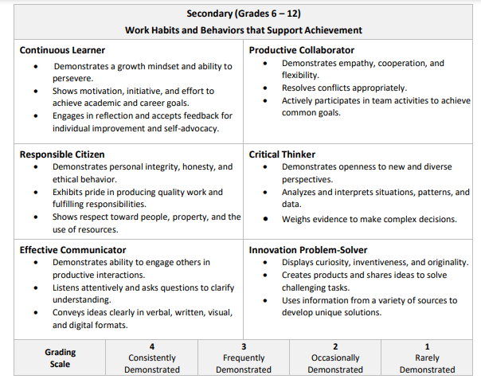

For this course grades will be assigned as follows:

        Major Grades  40%

        Minor Grades 60%

**School Expectations**

Follow all school rules and policies (P.R.I.D.E – PBIS).

* P – Principled
* R – Reflective
* I – Innovative
* D – Displined
* E - Excellence

**CLASS EXPECTATIONS**

**1.      Respect yourself, the teacher & others**

**2.   Put forth your best effort at all time**

**3.      Be prepared for class each day**

**4.      Follow directions when given**

**5.      Pay attention, participate and ask questions**

**6.      Preserve a positive learning environment**

**7.      Take responsibility for your actions.**

**CLASS RULES**

**1.**      **Cell Phone should be on silent and put away in bookbag**

**2.**      **No food or drink, except water**

**3.**      **Arrive to class on time & ready to learn**

**4.**      **Never line up at the door before dismissal**

**5.**      **Do not cheat, plagiarize, or copy work**

**6.**      **Use polite and appropriate language**

**7.**      **Do your best work & turn it in on time**

**CLASS PROCEDURES**

**1.**      **Turn in major and minor assignments in a timely matter**

**2.**      **Complete absent form for study buddy**

**3.**      **Pick up after yourself before you leave**

**4.**     **Get missed work from absent bin, talk to your study buddy, then ask the teacher**

**Classroom Consequences**

1. Verbal warning
2. Call home
3. Detention
4. Write-up
5. Parent Conference

  * All consequences will be aligned with the HHS school wide discipline plan.

**Course Materials Suggested Students may take notes online and use Desmos**

* **1 Large** Three-ring binder (1” or 2”) or Composition notebook
* Pencils
* 1 Package of Dividers (Label: Notes, vocabulary)
* Erasers
* Loose Leaf Paper
* Personal Computer or school issue computer( see media specialist for school issue computer)

**Conferences**

The primary goal is to meet the developmental needs of each student; therefore, student progress during each grading period will be closely monitored.  A **Parent conference should be scheduled for all students earning D’s and F’s prior to the end of each nine weeks grading period.**

**In order to schedule a conference with your teachers, please contact the Guidance Office 706-592-2089**

**Parents are welcome to join**

**Online Geometry**

Band App instructions will be given in class by the teacher

**KEEP THIS SYLLABUS IN THE FRONT OF YOUR MATH NOTEBOOK**

Signature Page

By signing below, we acknowledge that we have read and understand the: **Course Syllabus 2025 – 2026 Geometry**

Class Period ____________

Print Student Name _____________________________________________

Student Signature _______________________________________________  Date ____________________

Print Parent Name_______________________________________________

Parent Signature _________________________________________________ Date____________________